Options Flow Tracker
Changze Li, Lizhou Wang, Jiawei Qin, Shijun Zhao
Point of contact email addresses:
changzeli@vt.edu
jiaweiq@vt.com
lizhouw@vt.edu
shijunzhao@vt.edu
CS 4604, Dr. Nizamani
Spring 2026

Table of Contents
- Problem Definition ............................................................................................................. 3
- System Users and Privileges .............................................................................................. 3
- Entities and Their Descriptions .......................................................................................... 3
- Relationships and Their Descriptions ................................................................................ 4
- Entity Relationship Diagram (ERD) .................................................................................. 5

1. Problem Definition
This is a real-time options-flow tracking web application built around a database-centric pipeline and a user-facing decision layer. The system continuously ingests market feeds such as trades and quote/chain-derived fields, normalizes them into unified FlowEvent records linked to underlying symbols, and writes them into a structured store optimized for low-latency queries. On top of this foundation, it computes flow features such as notional, trade direction, aggressor side, and volume/open-interest anomalies using premium/price and bid–ask fields stored in FlowEvent and models option activity as FlowEvent records annotated with expiration and strike fields, linked to underlying symbols, so users can navigate data through connected entities rather than isolated records.
The platform then exposes this processed data through interactive modules: real-time alerts, filters, watchlists, and pre-defined screeners that translate raw flow into actionable views (e.g., unusual activity, repeated sweeps, volatility expansion, concentrated expiration risk). Unlike institution-oriented systems, this design focuses on individual workflows: fast search, explainable metrics, and configurable decision rules, enabling retail and independent traders to organize, analyze, and act on options-flow signals without managing complex infrastructure themselves.

2. System Users and Privileges
User Type 1: Retail Trader
Privileges:
- Read access to options flow trade records
- Read access to sentiment, trade type, and strategy classifications
- Create / Read / Update / Delete own watchlists
- Create, read, update, and delete personal filter presets
- Read access to ticker metadata
User Type 2: Market Analyst/Researcher
Privileges:
- All Retail Trader privileges
- Access historical options flow data across extended time periods
- Generate reports on options activity patterns
- Export filtered data to external formats (CSV)
User Type 3: Administrator
Privileges:
- Manage ticker metadata
- Manage system configuration tables
- Access running log
- Modify classification lookup tables

3. Entities and Their Descriptions
User: Represents an account that uses the platform. Stores identity and role information and is the owner of watchlists, presets, and alerts.
Asset: A reference entity that represents the category/type of a tradable instrument (e.g., Stock, ETF, Future, Index).
Ticker_Symbol: A unique abbreviation used to identify a publicly traded financial instrument on an exchange. It represents an underlying tradable asset and serves as the primary reference for aggregating all related trading data.
OptionContract: Represents a specific option contract defined by underlying symbol, expiration, strike, and call/put. Allows the system to connect flow data across strikes/expirations consistently.
FlowEvent (or Options/Trade record): Represents a normalized options-flow observation/trade event at a timestamp. This is the main fact entity used for filtering, alerts, and analytics.
Watchlist: Represents a user-defined collection of tickers to track.
Filter_Preset: Represents a saved set of filtering rules (stored as JSON) so users can quickly reproduce screeners.
Option_Strategy: Represents a strategy category/tag used to label flow events for analysis (e.g., sweep, spread, directional).
Sentiment_Classification: Represents sentiment categories/levels used to summarize flow direction/strength.

4. Relationships and Their Descriptions
- Asset contains Ticker_Symbol：Each ticker symbol is classified under exactly one asset type, while one asset type can contain many ticker symbols.
- Ticker_Symbol has OptionContract：Each underlying symbol can have many option contracts (different expirations/strikes/types), enabling navigation across the option chain.
- OptionContract generates FlowEvent：Flow events occur on specific contracts; this relationship supports contract-level filtering, aggregation, and anomaly detection.
- User own Watchlist：Watchlists are personal collections and must belong to exactly one user for authorization and customization.
- Watchlist includes Ticker_Symbol：A watchlist can contain many symbols and a symbol can appear in many watchlists, so a join entity is required.
- User owns Filter_Preset：Presets store a user’s reusable screener configuration and must be associated with a single owner.
- FlowEvent classified by Sentiment_Classification / Option_Strategy：Flow events are labeled with analysis categories so the UI can group, filter, and explain signals.

5. Entity Relationship Diagram (ERD)

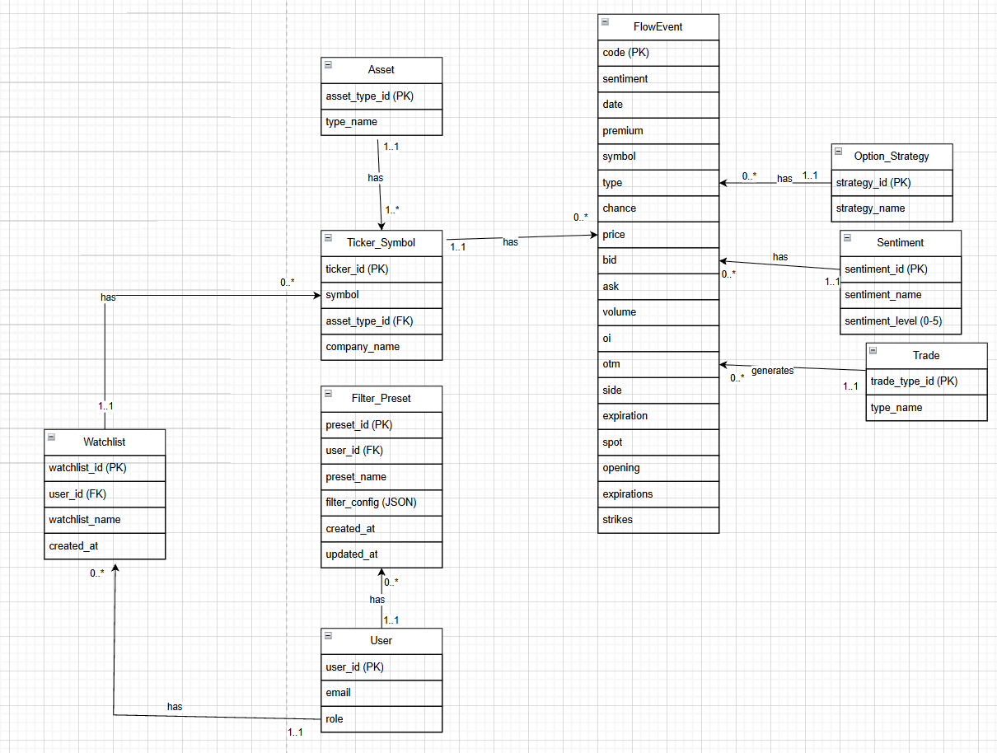

6. Team Roles and Contributions (Phase II)
Member 1: Lizhou Wang
Role and Contributions: Identify all finance-related database entities, and list and define the attributes required by users.
Member 2: Jiawei Qin
Role and Contributions: Check the reasonableness of the entities, and add some entity relationships.
Member 3: Changze Li
Role and Contributions: Identify and add some entity relationships, and check the construction of the ER diagram.
Member 4: Shijun Zhao
Role and Contributions: Construct all possible entities needed for building the database (not just finance-related entities). Define the entity relationships, and specify the cardinality of each relationship.
AI Team Member: Generative AI
Role and Contributions: Define the entities in the phase 2 report using professional knowledge in the financial domain, and check the reasonableness of the ER diagram.

